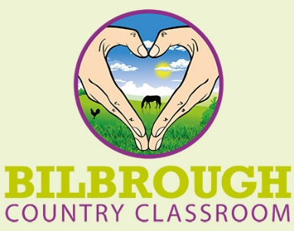

Provider: Bilbrough Country Classroom, The Orchards, 54a Back Lane, Bilbrough
York YO23 3PL.
Tel: 01937 831616
Lead: Rebecca Davison
E-mail: countryclassroombcc@gmail.com
Web: www.bilbroughcc.co.uk
Date: -------------
School or LA: -------------

I can confirm that all appropriate safeguarding checks have been carried out on the individuals working at Bilbrough Country Classrooms, as outlined in the Keeping Children Safe in Education (September 2023).

Legislation states for Alternative Provision Providers:
“Where a school places a pupil with an alternative provision provider, the school continues to be responsible for the safeguarding of that pupil, and should be satisfied that the provider meets the needs of the pupil. Schools should obtain written confirmation from the alternative provider that appropriate safeguarding checks have been carried out on individuals working at the establishment, i.e. those checks that the school would otherwise perform in respect of its own staff”.

I can confirm that the following checks are in place for all staff:
- Identity check
- Right to work in the UK
- Enhanced DBS and barred list
- For teachers: qualifications have been checked and Teaching regulations agency check to make sure they are not barred
- An overseas check if applicable.

R L Davison
Rebecca L Davison
Proprietor

